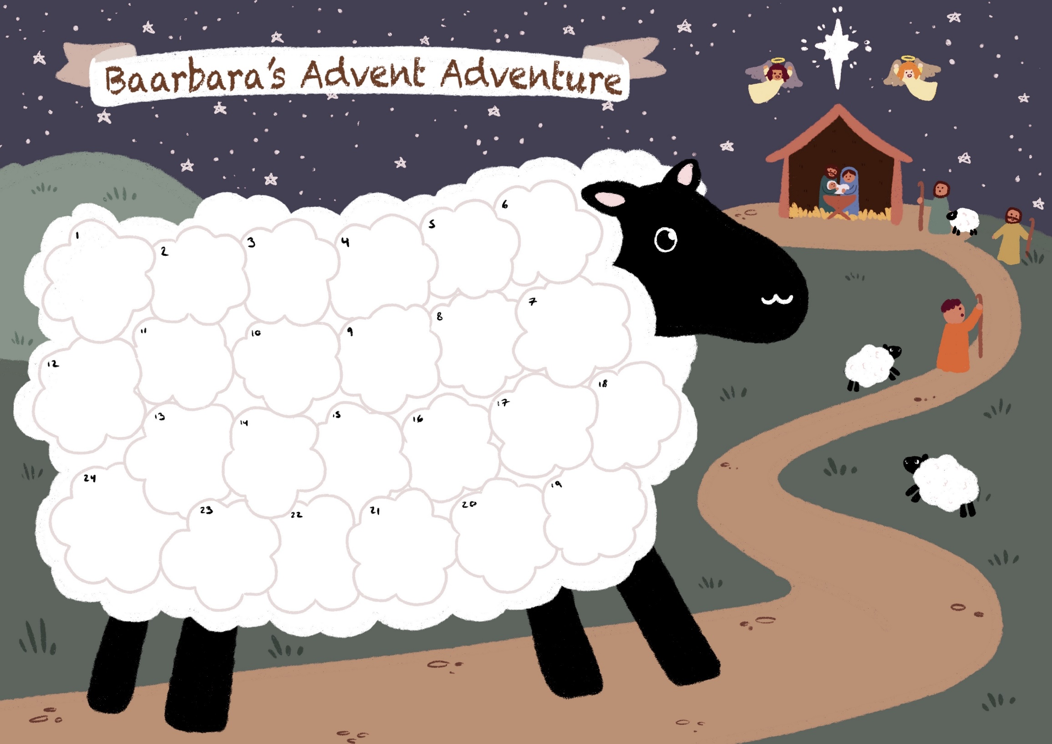

Stick the story here

Stick the story here 

|  |  |
| --- | --- |
| **Baarbara’s**  **Advent Adventure!** | After you’ve read the line in the Christmas story for that day, stick a cotton wool ball on Baabara, she is on her way to visit a new king. (You will need 24 cotton wool balls and a gold star or pen.) |
| **1 Today is the beginning of advent. Advent means coming or arrival.** | **14 There wasn’t a cot for a new baby, just a manger (food trough) filled with straw.** |
| **2 God wanted to send part of himself as a gift for everyone in the world. He decided to send his son Jesus.** | **15 Three wise men began to follow a bright star that**  **signaled the birth of the new King.** |
| **3 God chose a young lady called Mary to be his mum.** | **16 They asked the ruler Herod “Where is the new King?”** |
| **4 Mary was engaged to a carpenter called Joseph.** | **17 Herod was cross and planned to kill the new King** |
| **5 The Angel Gabriel visited Mary and she was frightened.**  **Baarbara was just munching grass at this point.** | **18 The three wise men did not go back to Herod and they bought gifts of gold, frankincense and myrrh.** |
| **6 The angel said “Don’t be afraid, you are special to God”** | **19 There were shepherds looking after their sheep in fields near to Bethlehem including Baarbara.** |
| **7 “You will have a baby boy, call him Jesus.” said the angel.** | **20 Angels appeared in a big flash of light.** |
| **8 Another angel appeared to Joseph in a dream and told him that the baby was very important and part of God.** | **21 The shepherds were frightened, an angel said “I bring GOOD NEWS!” Baarbara was sooo excited!** |
| **9 Mary and Joseph started a very long journey to Bethlehem, to take part in a census.** | **22 “You will find a baby, God’s son wrapped up warm in a manger.”** |
| **10 They travelled a long way, maybe they rode on a donkey.** | **23 All the angels sang praises to God “Glory to God in the Highest and peace to men on earth”. The shepherds took baabara and friends to see the baby.** |
| **11 When they arrived there was no where for them to stay.** | **24 Mary got some baby clothes ready for she felt that this would be a very special night** |
| **12 An innkeeper let them stay with his animals.** | **25 JESUS IS HERE! Well done Mary!**  You could stick gold star on the star in the picture today or colour it with a yellow or gold pen.  **Our present from God**  **HAPPY BIRTHDAY JESUS!** |
| **13 The cows and sheep were watching and waiting for the baby Jesus to arrive. Baarbara too felt something was in the air.** |  |